App in a Day
Hands-on Lab Step-by-Step

Contents
Importing Module 2 Completed 1
Task 1: Create a new environment 1
Task 2: Import the solution 2

Importing Module 2 Completed
Follow the steps below, if you did not complete Module 1 or Module 2 and would like to skip to Module 3

Task 1: Create a new environment
- Open a new browser tab, navigate to Power Apps admin portal select Environments and click New Environment.
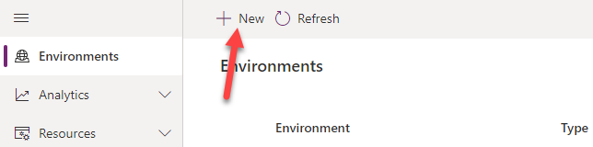
- Provide an Environment Name, select Trial for Type, select Region, select Yes, for Create a database, and click Next.
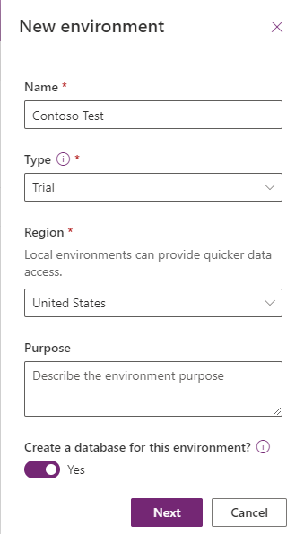
- Select Language, URL, and Currency. Click Yes for Deploy sample apps and data and then click Save.
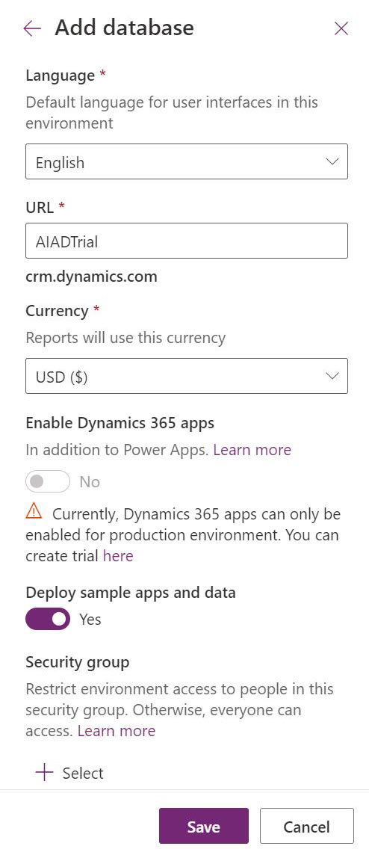
- Wait for the environment to be created.

Task 2: Import the solution
In this task, you will import the completed module 2 solution.
- Navigate to Power Apps maker portal
- Make sure you are in the Contoso Test Environment you created.
- Select Solutions and click Import solution.
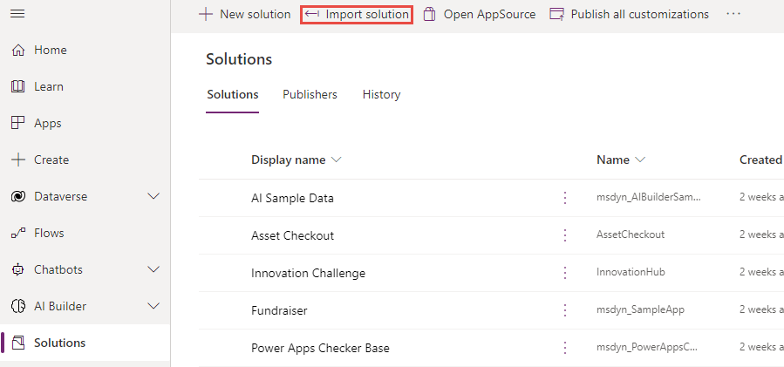
- Click Browse.
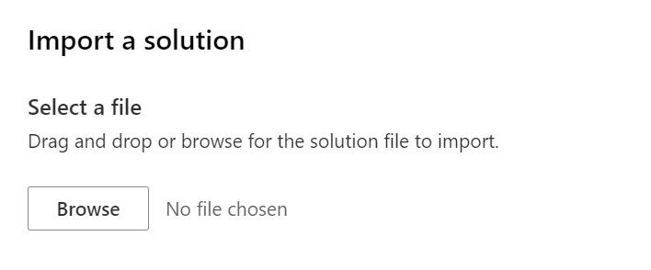
- Select the Conto Coffee solution zip file located in Module 2 Completed folder and click Open.
- Click Next.
- Click Import.
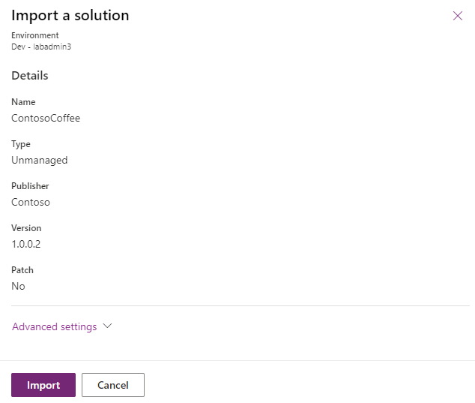
- Wait for the solution import to complete.
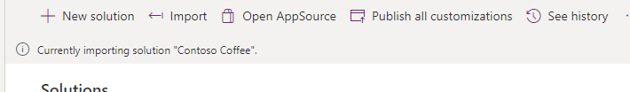
- Once the import is complete, Click Publish All Customizations and wait for the publishing to complete.
- Select Apps, click on the … button of the Machine Ordering App and click Play.
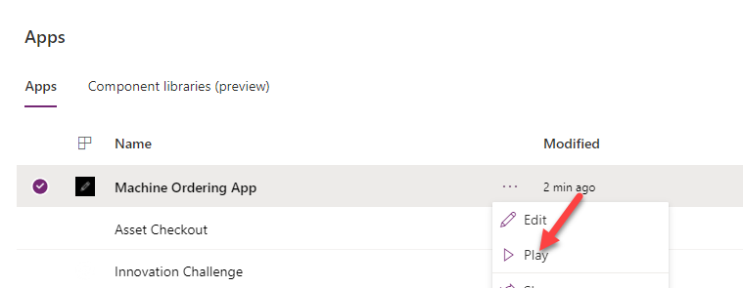
- Click Allow.
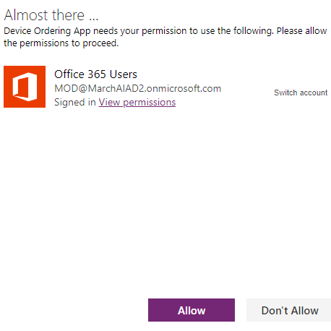
- Select a few machines and click Compare.
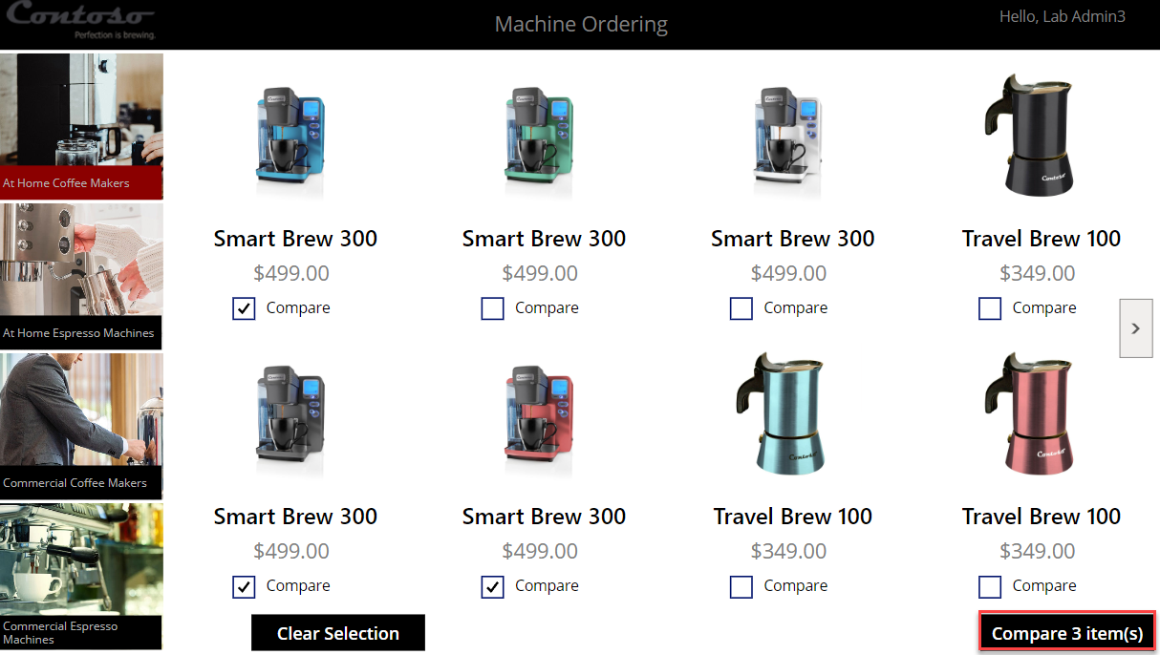

- Select one of the machines and click Submit.
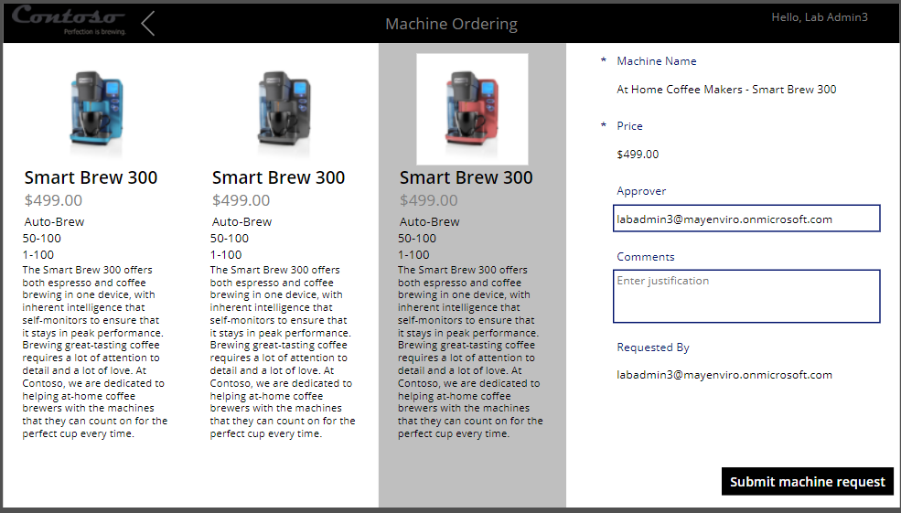
- Click OK.
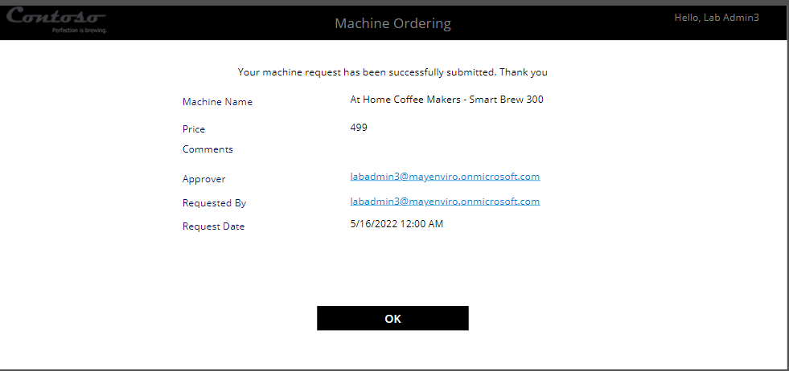
- Close the application.
- Expand Data, select Tables, search for Machine Order and click on it.
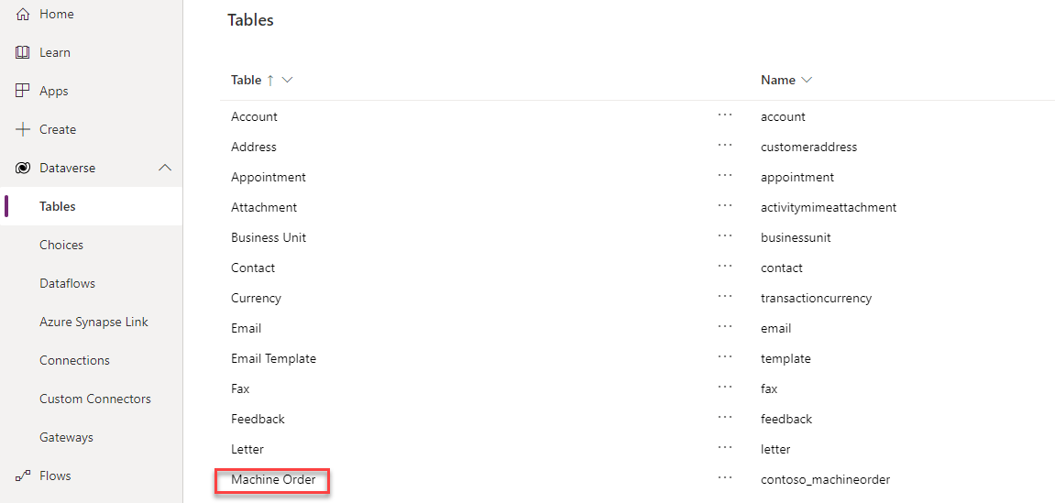
- Select the Data tab and make sure you have at least one record in the table.
